Year 10
Pathway 1

End of Term 1 Test 2017

Name: ______________________ Class: ______ Time: 50 minutes Total Mark:____/60

Show working and answers on this sheet. Show working in sufficient detail to support your answers. Incorrect answers without supporting reasoning will be allocated zero marks.

Resources: 1 A4 page of notes (1 side), Calculator allowed.

Question 1 4 marks

Specify if the following are rational (R) or irrational (I) numbers and Circle the surds

- $\sqrt{14.4}$ | - $\sqrt{1.44}$ | - $\frac{31}{58}$
- $4\sqrt{6}$

Question 2 10 marks

Simplify the following

- $7\sqrt{2}+9\sqrt{2}-3\sqrt{2}$ | - $12\sqrt{3}-8\sqrt{7}+5\sqrt{3}-10\sqrt{7}$
- $10\sqrt{6} ×3\sqrt{8}$ | - $5\sqrt{11}+7\sqrt{44}-9\sqrt{99}$
- $\sqrt{xy} × \sqrt{x^{3}y^{2}}$ | - $\frac{7\sqrt{44}}{14\sqrt{11}}$

Question 3 2 marks

Rationalise and simplify the following

- $\frac{\sqrt{15}}{\sqrt{6}}$

Question 4 – Fractional Indices 6 marks

- Evaluate the following

- ${16}^{\frac{1}{2}}$ | - ${27}^{\frac{1}{3}}$

- Simplify the following and leave in index form

- $4^{\frac{3}{5}} × 4^{\frac{1}{5}}$ | - $5x^{3} × x^{\frac{1}{2}}$ | - ${(a^{4}b)}^{\frac{3}{4}}$
- $\sqrt[3]{b^{9}}$

Question 5 11 marks

Evaluate the following.

- $\frac{2y}{3}+ \frac{4y}{3}$ | - $\frac{4x}{5}- \frac{x}{5}$
- $\frac{x+2}{4}+ \frac{x+6}{3}$ | - $\frac{2}{x+4}+ \frac{3x}{x-2}$
- $\frac{10xy}{7} ÷ \frac{20x}{14y}$

Question 6 3 marks

Solve for x.

- $\frac{x}{4}- \frac{x}{5} = \frac{3}{4}$

Question 7 6 marks

Solve, then check your answer by substitution.

- $5p ≤10$ | - $5+a> -3$
- $\frac{x}{2} <4$ | - $-2x≥31$
- $5a+5 ≥ -5$ | - $7x-5≤11-x$

Question 8 1 mark

Use the graphs to solve the simultaneous equations

- $y-3x =2$
$x-y =2$

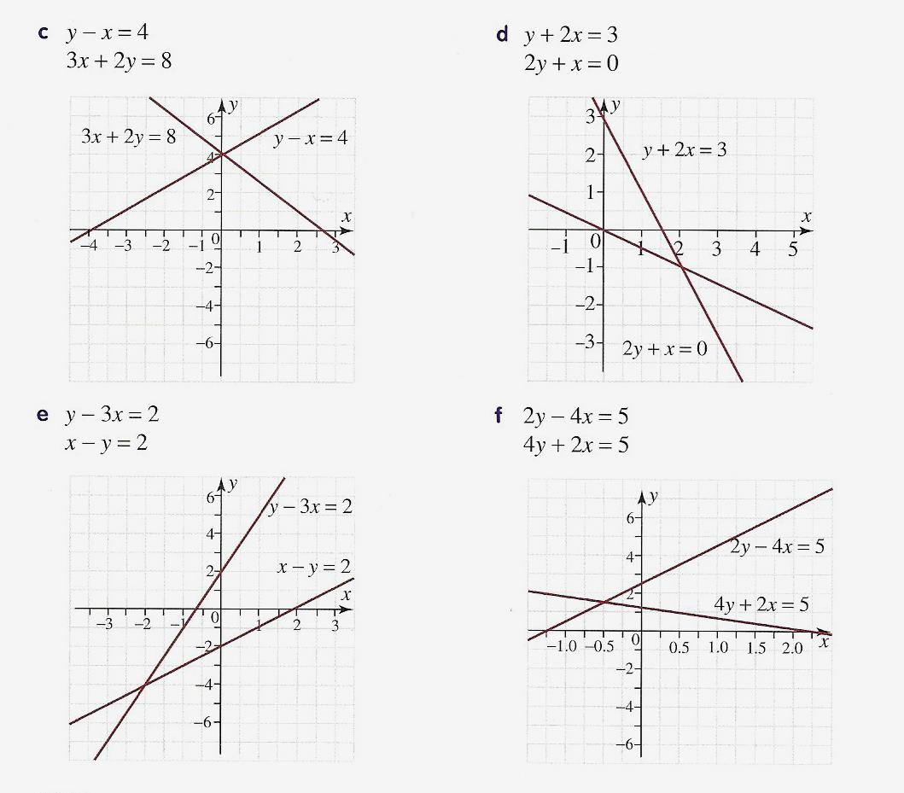

Question 9 4 marks

Use the graphical method to solve the following simultaneous equations.

$y =3$ and $x+y =5$

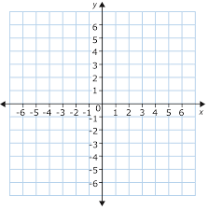

Question 10 4 marks

Solve the following simultaneous equations using the substitution method.

- $3x+4y =2$  $x =7+5y$ | - $y =2x+1$  $-5x-4y=35$

Question 11 4 marks

Solve the following simultaneous equations using the elimination method

- $x+2y =5$  $-x+4y =1$ | - $-3x-y =8$  $-3x+4y =13$

Question 12 5 marks

Solve the following

- The difference between two numbers is 2. If three times the larger number minus double the smaller number is 13, find the two numbers

END OF TEST

(THIS PAGE HAS BEEN LEFT BLANK INTENTIONALY)

